1. Git Config –global user.name “”
2. Git config –global user.email “”
3. Git config –list
4. Stage in list

Untracked/Modified Staged Committed

Git repo/ Directory

Staging Area

Working Directory

Ckeckout File

Staged File

Committed File

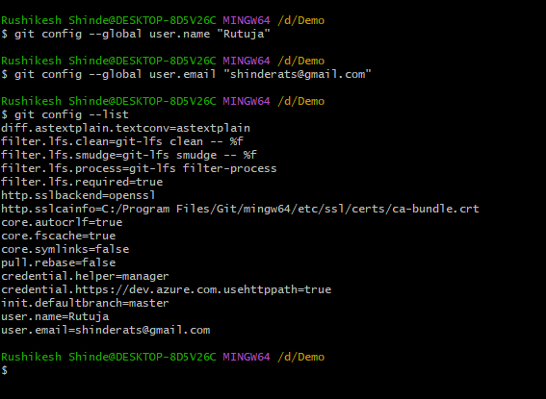

1. Git status
2. Git init

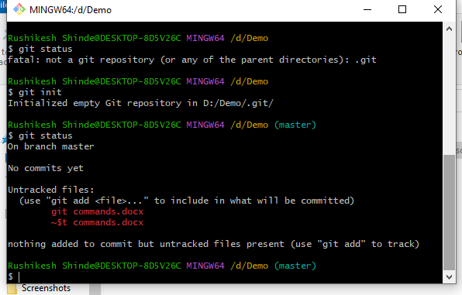

1. 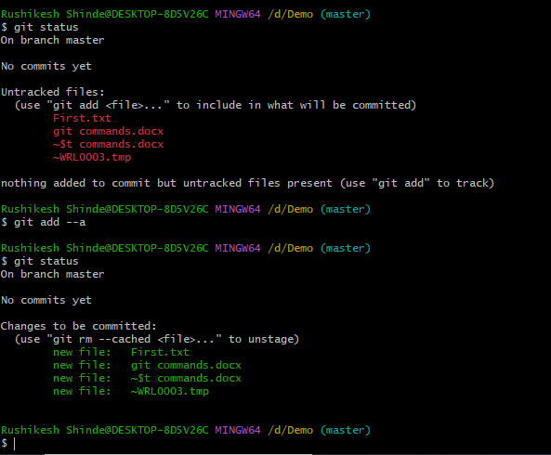
2. Git add –a : add all the files
3. Git commit -m “ creating first.txt”: add message
4. Git add first.txt: add specific file
5. Git log
6. 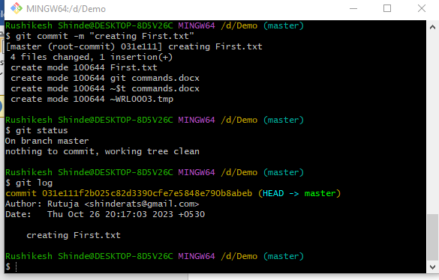
7. 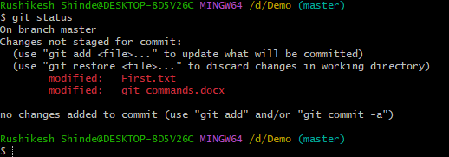
8. Git commit -m “updating First.txt”
9. Create new file
10. 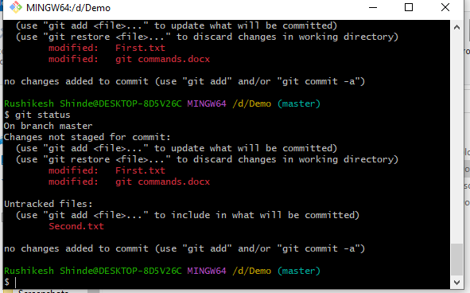
11. 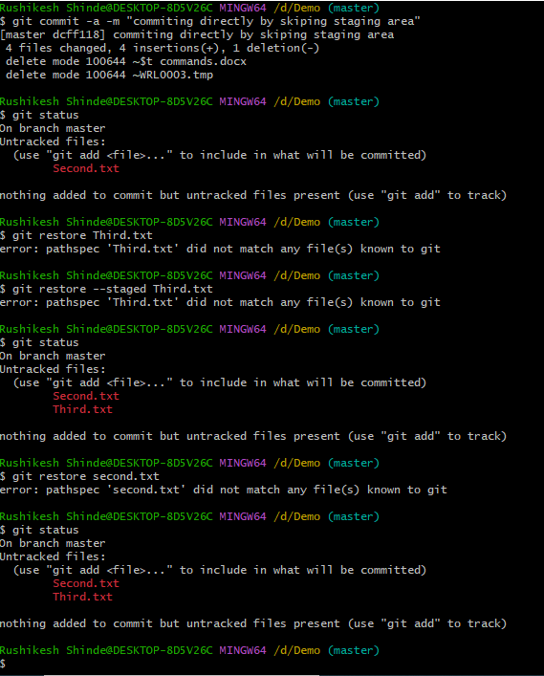
12. 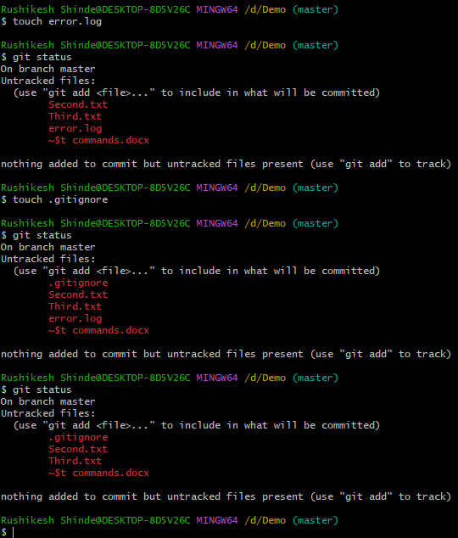
13. 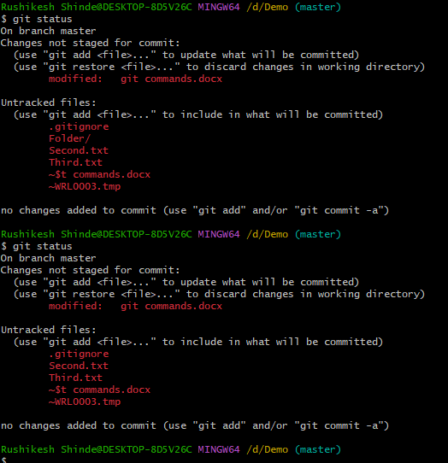
14. Github.com
15. Sign up